CHAPTER V

INTERNAL CONTROL MECHANISM and INTERNAL AUDIT
HEALTH, MEDICAL AND FAMILY WELFARE DEPARTMENT
5.1 Internal Control Mechanism in Family Welfare Department
Highlights
Internal control system is an integral process by which an organisation governs its activities to effectively achieve its objectives. Such a system consists of methods and policies designed to prevent fraud, minimize errors, promote operating efficiency, and to achieve compliance with established policies and helps to protect resources against loss due to waste, abuse and mismanagement. An evaluation of the internal controls and internal audit system in the Family Welfare Department during the period 2000-05 revealed the weakness of the internal controls in vogue in the Department, non-compliance with rules, manual, codes in the areas of budget preparation, expenditure control, implementation of family welfare programmes.
- Budget Estimates (BEs) for the years 2000-01 to 2002-03 were prepared without any inputs from the Department as the Commissioner did not submit the estimates. For the years 2003-04 and 2004-05, Commissioner prepared and submitted the BEs without any inputs from the Estimating Officers. These led to substantial savings of scheme funds, during the last three years.
[Paragraphs 5.1.5 and 5.1.6]
- The Commissioner had not maintained records to watch the receipt of monthly expenditure statements from the DMHOs. Reconciliation of the amounts kept in banks was also poor.
[Paragraph 5.1.7]
- DHMOs, Kurnool and Warangal made advances to Medical Officers of PHCs and CHCs on hand receipts out of amounts drawn on AC bills for payment to FP beneficiaries. District level Action Plans were not prepared by the DMHOs under the State Population Policy, so far. These were indicative of poor operational controls in the Department leading to deficient implementation of FW schemes.
[Paragraphs 5.1.9 and 5.1.10]
- A large number of key posts particularly of the Multi Purpose Health Assistants (MPHAs) and the Family Welfare (FW) Workers remained vacant as of March 2005, which adversely affected the implementation of the FW programmes. Due to delay in completion of training to the staff on computer work, services of temporary operators were continued leading to extra salary burden of Rs 1.74 crore.
[Paragraphs 5.1.11 and 5.1.12]
- Nothing has been specified in the Departmental Manual regarding the number of departmental inspections of the sub-ordinate offices to be conducted, nor did the Commissioner issue any instructions in this regard. No records of number of units/offices to be inspected and actually inspected were maintained indicating inadequate supervisory control.
[Paragraph 5.1.13]
- There was no manual for conduct of internal audit. Only two Assistant Audit Officers were in place to cover 100 subordinate offices and 1703 DDOs, besides the grants-in-aid institutions. During the period 2000-05, Internal audit of 55 (out of 100) offices/institutions was in arrears and 320 Internal audit paras (for 2000-05) remained outstanding.
[Paragraphs 5.1.14 to 5.1.16]
5.1.1 Introduction
Internal control consists of rules, orders and procedures designed to provide management with a reasonable assurance that the entity is functioning in the manner intended and is likely to achieve its objectives. A good internal control system should enable managers to ensure efficient, effective and economic utilisation of resources. Internal auditors as an independent entity, examine and evaluate the level of compliance to the departmental rules and procedures and provide independent assurance to the management on the adequacy or otherwise of the existing internal controls.
Audit carried out an evaluation of the Internal Control Mechanism and Internal Audit System in the Family Welfare Department, a part of the Health, Medical and Family Welfare Department.
The overall objective of the Department is population stabilisation which is sought to be achieved through activities such as conduct of family planning (FP) operations, supply of contraceptives, oral pills, providing ante-natal and post-natal care to women for child survival and safe motherhood, immunisation to infants and children and healthcare.
5.1.2 Organisational set up
The Department is part of the Health, Medical and Family Welfare Department and is headed by the Commissioner of Family Welfare (Commissioner), who is also the ex-officio Secretary, Family Welfare Department. He is assisted by one Additional Director, three Joint Directors (JD), three Deputy Directors (DD), one Assistant Director (Administration),
one Accounts Officer, Cold Chain Officer, two Assistant Audit Officers (Internal Audit). At district level, the District Medical and Health Officer (DMHO), assisted by Additional DMHO, Deputy DMHOs, Administrative Officer, Medical Officers and Paramedical staff are responsible for implementation of the family welfare programmes. As of March 2005, there were 48 Community Health Centres, 1386 Primary Health Centres (PHCs), 131 Urban Family Welfare Centres, 82 Post-Partum Units in teaching and non-teaching hospitals at district and sub-district level and 12522 sub-centres catering to the family welfare services in the State.
5.1.3 Audit objectives
The audit objectives were to examine the adequacy and effectiveness of
- Financial controls
- Administrative and operational controls
- Manpower management
- Supervisory controls
- Internal Audit System
5.1.4 Scope of Audit
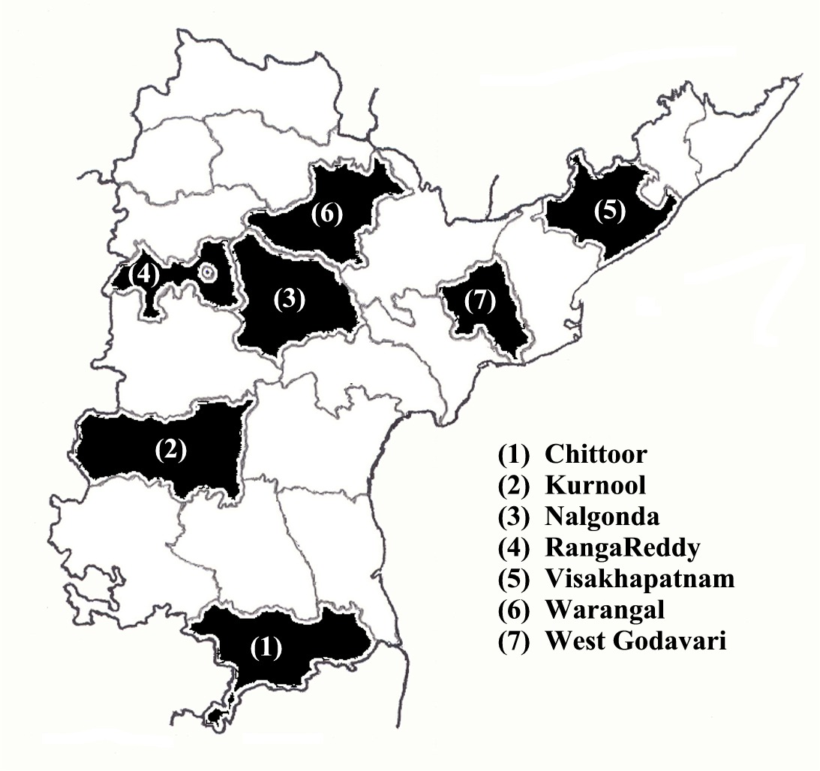
Audit review of the adequacy and effectiveness of the internal control mechanism, including internal audit arrangement in the Department for the period 2000-05 was conducted at the Secretariat, the Commissioner’s office and seven DMHOs. Audit covered a few Primary Health Centres, Post-partum Units, Urban Family Welfare Centres, etc. in each selected district. The results of the review are discussed in the succeeding paragraphs.
Financial controls
Audit observed that budget estimates were either not submitted or submitted late and the expenditure statements of the Department were not prepared by the Controlling Officers (CO), which indicated ineffective and weak budgetary and expenditure control.
5.1.5 Budgetary controls
According to the Budget Manual the Controlling Officers (COs) are required to send the Revised Estimates (REs) for the current year and the Budget Estimates (BEs) for the next year to the Chief Controlling Officer (CCO) who in turn has to send it to the Administrative Department by 1 October every year to enable it to submit the estimates to the Finance Department by 15 October every year.
Commissioner prepared the BEs without any inputs from the estimating officers
The Commissioner did not submit the BEs to the administrative department for the years 2000-01, 2001-02 and 2002-03. Consequently, the Finance Department finalised the BEs without necessary inputs from the Department. For the years 2003-04 and 2004-05, the Commissioner submitted the BEs directly to the Finance Department without any inputs from the estimating officers. The BEs for 2003-04 were was submitted after a delay of 94 days, leaving limited scope for examination of the estimates by the Finance Department.
Finance Department finalised the BEs without necessary inputs from the Department
As the administrative department at Government level was not involved in the budgetary process there were excess provision and huge savings.
Budget provision vis-à-vis expenditure of the Department during 2000-05 was as under.
(Rupees in crore)
Year | Budget provision | Expenditure | Saving (Percentage)
2000-01 | 295.20 | 272.75 | 22.45 (8)
2001-02 | 290.40 | 272.62 | 17.78 (6)
2002-03 | 318.53 | 253.43 | 65.10 (20)
2003-04 | 431.63 | 275.70 | 155.93 (36)
2004-05 | 394.60 | 302.29 | 92.31 (23)
Total | 1730.36 | 1376.79 | 353.57 (20)
5.1.6 Savings due to excess provision over the Department’s estimate
It was noticed in audit that during 2002-03, funds provided under certain programmes were excessive and remained unspent, resulting in surrender (February 2003) of Rs 3.26 crore. During 2003-04, expenditure incurred under five schemes/sub-heads was Rs 123.09 crore for which Commissioner sought for allocation of Rs 138.30 crore. Budget provision was, however, made for Rs 245.44 crore, ignoring the estimates of the Commissioner. This resulted in huge saving of Rs 122.35 crore, as shown below. Of these, savings of Rs 97 crore were surrendered.
Against Department’s estimate of Rs 138.30 crore provision was made for Rs 245.44 crore
(Rupees in crore)
Sub-Head | Allocation sought for by the Commissioner  in BEs | Budget provision | Actual expenditure | Saving
Rural Family Welfare Services – Sub-centres | 102.99 | 140.14 | 79.07 | 61.07
Urban Family Welfare Service centres | 11.31 | 12.30 | 6.63 | 5.67
Compensation to FP acceptors (CSS) | 24.00 | 40.00 | 17.06 | 22.94
Construction of Family Welfare buildings | NIL | 10.00 | NIL | 10.00
RCH National Component | NIL | 43.00 | 20.33 | 22.67
Total | 138.30 | 245.44 | 123.09 | 122.35
5.1.7 Expenditure controls
It was observed that though required under the Budget Manual of the State, the Commissioner neither monitored the receipt of monthly expenditure statements from the 23 DMHOs in the Department, nor watched the progress of expenditure. He also did not consolidate the expenditure figures of the DMHOs nor reconcile those with the expenditure figures of the Accountant General. Thus, the prescribed expenditure controls in the Department were bypassed and expenditure figures booked by the AG were collected for inclusion in the BEs.
Prescribed expenditure controls were bypassed
For implementation of various FW schemes, the Commissioner operated eight bank accounts and deposited moneys drawn from treasury and those received from GOI. Audit observed that the Commissioner did not reconcile the balances available as per his cash book with the balances as per Bank passbooks. As a result, large variations between the balance as per Bank statements and the balance in Commissioner’s cashbook as of March 2005 (Appendix 5.1) remained unreconciled. Cash management was clearly far from satisfactory.
Variation between balances as per cash book and balances in bank pass book was not reconciled
5.1.8 Poor recovery of loans sanctioned to ANMs
With a view to enhancing the mobility of the Auxiliary Nurse Midwives (ANMs), GOI sanctioned Rs 7.96 crore (Rs 2.56 crore in December 1998 and Rs 5.40 crore in March 1999) as grants for providing interest free loans for purchase of mopeds for the ANMs. Audit observed (February 2005) that out of Rs 2.56 crore sanctioned, loans of Rs 2.15 crore were paid to 1341 ANMs during the period June 1999 - December 2000. Though the loan was to be recovered in full by December 2004 (in 50 monthly instalments), Rs 0.70 crore was not recovered as of August 2005. The arrangement to keep watch over the recovery of loans was not satisfactory.
Loans amounting to Rs 0.70 crore were not recovered
Administrative controls and operational controls
State Government had been implementing various Central and State Government schemes to provide family welfare services to the public. Audit observed non-compliance of financial rules and prescribed guidelines in implementation of the schemes which was mainly due to weak administrative and operational controls in the Department. This also resulted in under-achievement of the targets under these programmes, as discussed below.
5.1.9 Deficient implementation of FW schemes
Cash compensation to Family Planning (FP) acceptors for Tubectomy (at the rate of Rs 500 to each BPL beneficiary and Rs 120 for each APL beneficiary) and for Vasectomy (Rs 130 to BPL beneficiary) are paid based on income certificates issued by an officer of the Revenue Department not below the rank of Mandal Revenue Officer (MRO). Audit scrutiny revealed the following irregularities:
- Medical Officers (MOs) of the PHCs and the CHCs are empowered to draw a maximum of Rs 8000 and Rs 10000 respectively on AC bills, on each occasion. It was observed that the MOs exceeded the limit in Nalgonda (three bills in 2001-02 and five bills in 2004-05 were drawn for Rs 50,000 each) and West Godavari (two bills of Rs. 15,000 each drawn in 2004-05) districts for payment of incentive to FP acceptors.
- In RangaReddy District, FP incentive was paid by the MOs, on self-declaration of income and BPL status by FP acceptors.
- In Kurnool District, payments were made on the basis of income certificates issued by the Medical Officers.
- In four districts (Chittoor, Nalgonda, RangaReddy and Warangal) compensation to FP acceptors was paid for sterilisations conducted in private medical institutions without verification of records of those institutions.
- During 2000-05, DMHOs in Kurnool and Warangal made advances (ranging from Rs 1000 to Rs 50000) to Medical Officers of PHC/CHCs on simple hand receipts from out of the amounts drawn on AC bills for payment to FP beneficiaries. DMHOs did not however maintain any register to watch the adjustment of advances. The amounts advanced were kept out of government account for three to six months until these were adjusted in the respective DC bills.
- The DMHO, Chittoor, retained scheme funds of Rs 16.09 lakh during the period from October 2003 to April 2005.
A DMHO retained scheme funds of Rs 16.09 lakh for 19 months
It is evident from the above that the scheme implementing agencies did not adhere to the financial rules and the scheme guidelines and functioning of control mechanism at higher levels was ineffective.
5.1.10 State Population Policy - demographic goals not achieved
To achieve the main demographic goal of population stabilization set out in Vision 2020, the Government introduced the State Population Policy (SPP) in 1997 which included reduction of Maternal Mortality Rate, Infant Mortality Rate and increase of Couple Protection Rate. District Population Stabilisation Societies were established for implementation of specific interventions such as “round-the-clock” PHCs, training to doctors in laparoscopic techniques. These societies were responsible for formulation, implementation, monitoring and review of all interventions of SPP. Audit scrutiny revealed the following:
Demographic goals not achieved due to poor monitoring; scheme funds of
Rs 1.19 crore remained unutilised or lapsed to Government
- District level Action plans were not prepared by the DMHOs, under the SPP.
- Out of 161 annual expenditure statements due to be received from the 23 societies in 23 districts(for the period 1997-98 to 2003-04), only 33 statements were received from 10 districts. The Commissioner, however, provided funds to the District Societies even without receipt of the annual audited accounts.
- During 2002-03, scheme funds of Rs 1.19 crore paid to five district societies either remained unutilised or were paid back to Government account as per orders of the Government.
- In Kurnool, Nalgonda and Warangal Districts, the Divisional Officers/Deputy DMHOs did not maintain the camp-wise expenditure details for the FP operations.
- Scheme-wise cash books were not maintained by the DMHOs in Kurnool and RangaReddy Districts.
The above points reflect weak financial and operational controls both at DMHOs and Commissioner level which also had adverse impact on the implementation of the FW programmes and led to non-achievement of the goals set for the year 2000 in respect of CBR, CDR, IMR and TFR, as the following table shows.
S. No. |  | Targets fixed |  | Targets achieved  as of October 2005
S. No. |  | 2000 | 2010 | Targets achieved  as of October 2005
1 | Natural Growth Rate percentage | 1.15 | 0.80 | 1.24
2 | Crude Birth Rate (CBR)* | 19.0 | 15.0 | 20.40
3 | Crude Death Rate (CDR)* | 7.5 | 7.0 | 8.00
4 | Maternal Mortality Rate (MMR)** | 2.0 | 1.2 | 1.54
5 | Infant Mortality Rate (IMR)** | 45 | 30 | 59.00
6 | Couple Protection Rate (CPR) | 60 | 70 | 63.20
7 | Total Fertility Rate (TFR) | 2.1 | 1.5 | 2.25
* per thousand population ** per thousand live births

Manpower management
Overall manpower management in the Department was inadequate adversely affecting the programme implementation and also leading to waste of resources, as discussed below.
5.1.11 Vacancies in key posts
The performance of the department and efficient implementation of the Family Welfare programmes depends on availability of the required manpower. Audit however observed that a considerable number of key posts such as MPHA (Male) (21 per cent) and FW Workers (20 per cent) remained vacant as of August 2005. Besides, there were vacancies in the posts of Health Extension Officers (8 per cent) and Medical Officers (6 per cent). The Commissioner did not effectively pursue with the Directorate of Health the matter of deployment of staff against the vacant posts. Huge vacancies in MPHA posts adversely affected the identification and mobilisation of Family Planning acceptors. Government stated (October 2005) that vacancies in MPHA posts could not be filled due to pendency of a case in the High Court.
Large vacancies existed in the key posts of MPHAs and FW Workers
5.1.12 Services of temporary staff continued due to lack of trained staff
Under the programme of Computerisation of PHCs (FHIMS application), training on computerisation i.e., database and FHIMS application was to be imparted to the field staff, supervisory staff and Medical Officers. With a view to providing support to the PHC staff till they get trained, 1340 Data Processing Operators (one at each PHC up to October 2004 and thereafter one for two PHCs) were appointed on temporary basis for six months during November and December 2003. Audit observed that only the training on database was completed and that for FHIMS application was not taken up as of May 2005. Due to non-completion of training (in FHIMS software) to staff, the services of 676 DP Operators were continued beyond the stipulated period of six months, which resulted in additional expenditure of Rs 1.74 crore on their salaries for the period from July 2004 to March 2005. The Government stated (October 2005) that FHIMS application training could be taken up only in June 2005 since the local institutes were not in a position to provide infrastructure facilities for the FHIMS application software training. The reply was not acceptable as this aspect should have been foreseen before taking up computerisation of PHCs.
Temporary Operators were retained for computerization work; extra burden on account of salaries was Rs 1.74 crore

Supervisory controls
The extent of departmental inspection of various FW activities to be conducted was not prescribed in the Departmental Manual. The Commissioner and the DMHOs also maintained no records in this regard, as discussed below.
5.1.13 Poor monitoring of Departmental Inspection
As per the guidelines indicated in the Functionary Manual of the Department, the Joint Directors, Deputy Directors and other Programme Officers were required to conduct inspection of subordinate offices under their control in order to ensure proper implementation of various FW schemes implemented by the Department. The manual did not contain provisions regarding the number of inspections to be conducted by each DMHO and Programme Officer. No administrative instructions were also issued by the Commissioner prescribing the number of inspections to be carried out.
Departmental manual did not contain number of inspections to be conducted; no instructions issued by Commissioner
The Commissioner did not maintain any records indicating the number of units or offices to be inspected and the extent of inspections actually conducted by the concerned officers. He however replied (August 2005) that the Additional Director and the Joint Directors conducted inspections regularly but did not produce any document in support of his statement.
No records maintained for departmental inspections
The DMHOs were also to inspect the CHCs, the PHCs and the offices of the programme officers at least once in a year. Though the DMHOs replied (April - May 2005) that they conducted such inspections, no document in support of their inspection could be made available to Audit.
The above points indicated ineffective supervision and monitoring of the implementation of various FW schemes by the Commissioner and the DMHOs. This affected the operating efficiency of the Department and proper implementation of the schemes.

Internal Audit
Internal Audit (IA) was to examine and evaluate the level of compliance to the departmental rules and procedures so as to provide assurance to the Management on the adequacy of the internal control system of the Department. Internal audit in the Department was however quite inadequate as discussed below.
5.1.14 Insufficient arrangement for Internal Audit Wing
The Department did not have any manual on internal audit nor did they prescribe the duties and responsibilities of the Internal Auditors. No training was imparted to the staff in Internal Audit methodology and techniques as of August 2005.
No Manual for Internal Audit
The staff sanctioned for the Internal Audit wing consisted of three Assistant Audit Officers, three Senior Assistants and three Junior Assistants. The audit programmes and reports were submitted through Accounts Officer for approval by the Commissioner.
Only two AAOs were in position against the sanctioned strength of three (without any supporting staff) to cover the entire State with more than 100 sub-ordinate offices and 1703 DDOs and other grant receiving institutions. No supervision was made by the Accounts Officer. This indicated that little importance was given to Internal Audit.
Only two AAOs were in place to conduct audit of 100 offices and 1703 DDOs
5.1.15 Huge arrears in internal audit
Records relating to the identification of grant receiving institutions for internal audit (forecast registers) were not maintained by the IA wing. No system was evolved for fixing the periodicity, coverage and duration of audit of sub-ordinate offices. Internal Audit was in arrears in respect of 55 offices/institutions (out of 100) for the five-year period 2000-05 alone. The internal audit of the Commissionerate was also not conducted since 1989.
Internal Audit was in arrears for 55 institutions for the period 2000-05 alone
5.1.16 Pendency in settlement of Internal Audit observations
Audit observed that the Commissioner did not watch the settlement of internal audit observations. As of March 2005 a total number of 320 paras relating to 50 internal audit reports pertaining to the accounting years 1988-89 to 2003-04 were pending. There was no clearance of audit observations during the last five years except 63 paras in respect of two institutions. Objection Registers for watching money value objections were also not maintained. Thus the deficiencies pointed out in the internal audit reports were ignored by the Department defeating the very purpose of internal audit system.
320 Internal Audit paras were not settled
Due to inadequate and ineffective Internal Audit, no assurance was available to the Department about compliance with the rules and prescribed procedures.
5.1.17 Conclusions
Internal controls in the Department were weak. Because of weak budgeting discipline, 36 per cent of the funds provided in 2003-04 and 23 per cent in 2004-05 remained unspent leading to huge surrender of funds even after reappropriation. The Commissioner had not maintained records to watch the receipt of Monthly Expenditure Statements from DMHOs. District level action plans were not prepared by the DMHOs as required under the State Population Policy indicating poor operational controls in the Department. The Departmental Manual did not specify the number of inspections of the sub-ordinate offices to be carried out by the officers nor were any instructions issued in this regard. Records of inspection carried out were not maintained. Only two Assistant Audit Officers were in place for conducting the internal audit of 100 subordinate offices and 1703 DDOs. There was no Manual for conducting internal audit.
5.1.18 Recommendations
- Timely submission of budget estimates as well as the monthly expenditure statements may be ensured to avoid the situation of excess provisions and subsequent surrender of savings as well as to enforce the necessary expenditure control measures in the Department.
- The Commissioner should ensure timely and regular reconciliation of balances of the funds kept in banks with balances in the departmental cash book.
- Internal audit wing should be strengthened to cover all the units at regular intervals. Timely corrective action on the internal audit reports should also be ensured.
- The extent to which superior officers should inspect the field should be clearly laid down by the Department and necessary follow-up action on the inspection reports ensured.

Hyderabad  The | (S. B. PILLAY)  Sd/-  Principal Accountant General (Civil Audit)  Andhra Pradesh
 | Countersigned
New Delhi  The | (VIJAYENDRA N. KAUL)  Sd/-  Comptroller and Auditor General of India

Chittoor, Kurnool, Nalgonda, RangaReddy, Visakhapatnam, Warangal and West Godavari
Area Project/IPP.VI (Rs 50 lakh); State Institute of Health and Family Welfare (Rs 25.50 lakh); Sukhibhava (Rs 2.50 crore)
Adilabad (three), Anantapur (five), Chittoor (five), Hyderabad urban (four), Kadapa (four), Kurnool (five), Prakasam (one), Vizianagaram (two) and Warangal (four)
Nalgonda (Rs 15.39 lakh); Warangal (Rs 30.86 lakh); Kurnool (Rs 21.12 lakh); RangaReddy (Rs 20 lakh); West Godavari (Rs 31.61 lakh)
Family Welfare Health Information Management System
DMHOs, government maternity hospitals and grantee institutions
conducted during the period 2000-05

