REPORT OF THE
COMPTROLLER AND AUDITOR GENERAL OF INDIA
FOR THE YEAR ENDED 31 MARCH 2010 (LOCAL BODIES)
GOVERNMENT OF ANDHRA PRADESH
HOME |  | PREFACE | OVERVIEW
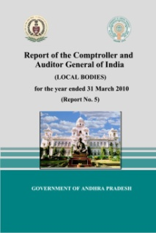 | Audit paras pertaining to  MUNICIPAL ADMINISTRATION AND URBAN DEVELOPMENT DEPARTMENT
Municipal Administration And Urban Development | OVERVIEW OF ACCOUNTS AND FINANCES OF LOCAL BODIES
Panchayati Raj And Rural Development | Sn-A Overview of Accounts and Finances of Local Bodies
 | Sn-B Financial Reporting
 | Performance Audit:
 | 2.1 Functioning of Anantapur Municipal Corproation in Sanitation, Water supply, Property tax, Shopping complexes and Municipal schools
 | Transaction Audit paras:
 | 3.2.1 Irregular raising of loan
 | 3.2.2 Construction of Rain water harvesting pits
 | 3.2.3 Undue benefit to contractors
 | 3.2.4 Non augmentation of revenue
 | 3.2.5 Payment of family pension
HOME

