HOME
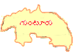
2.2
2.2.6
2.2.6.1
2.2.6.2
2.2.6.3
2.2.7
2.2.7.1
2.2.7.2
2.2.7.3
2.2.7.4
2.2.8
2.2.9
3.2.3
HOME

