HOME
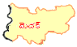
3.1.4
3.2.4
HOME

