HOME
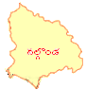
3.1.3
3.2.2.
HOME

