HOME
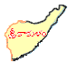
3.2.2.
HOME

